Part 1
Schematic for XORC (Complementary style XOR gate)
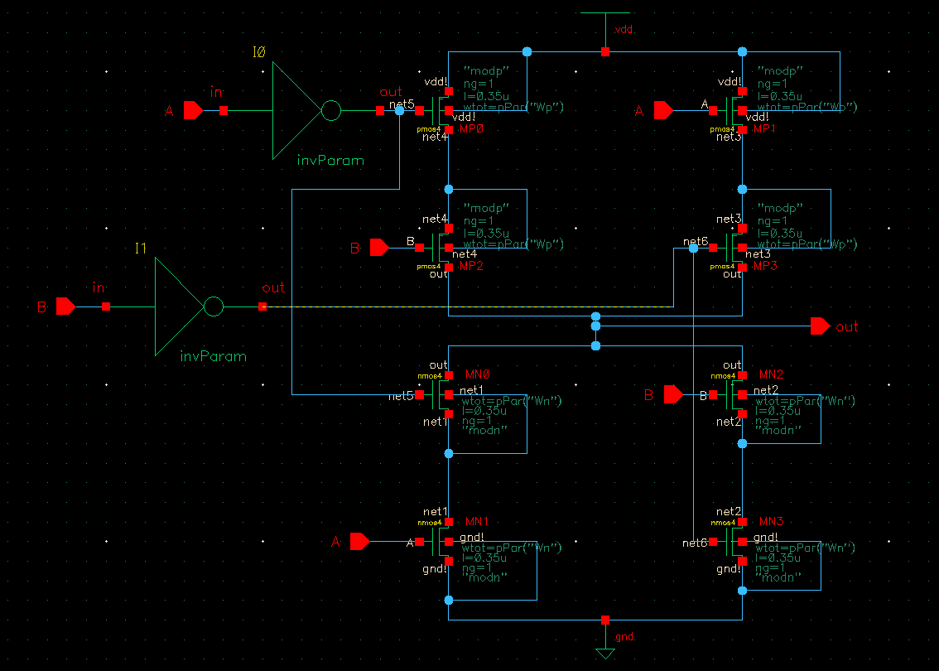

Schematic for XORT (Transmission gate implementation of XOR gate)
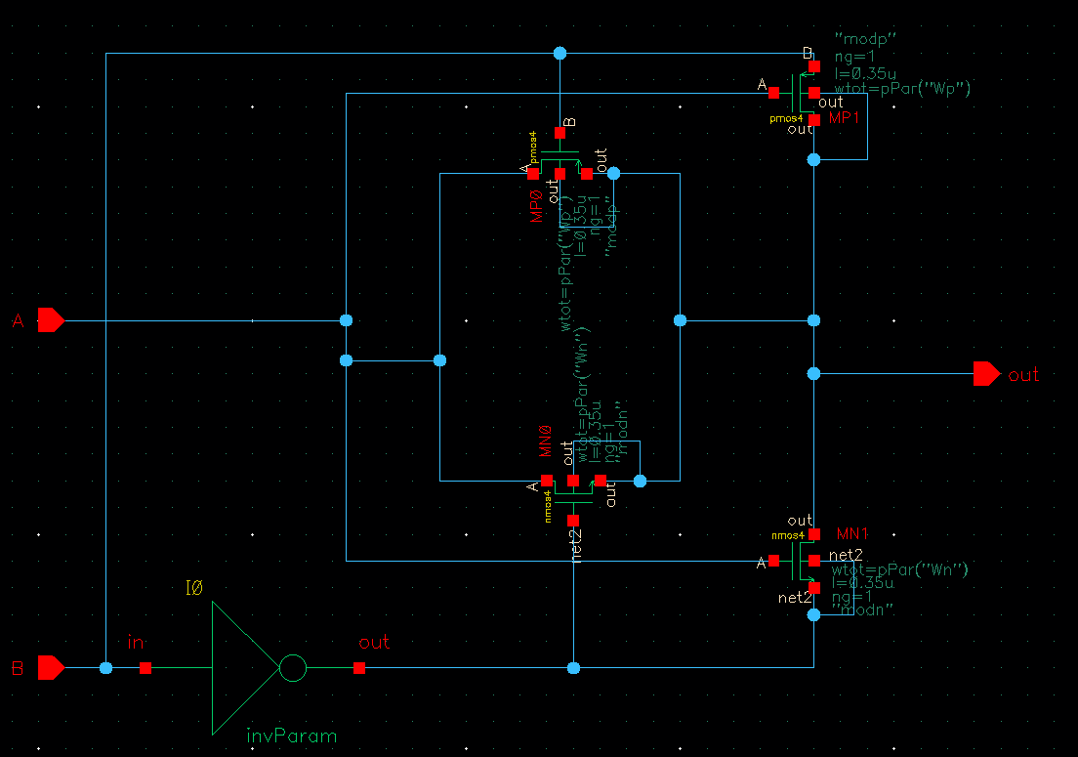

Part 2
Testbench output for XORC
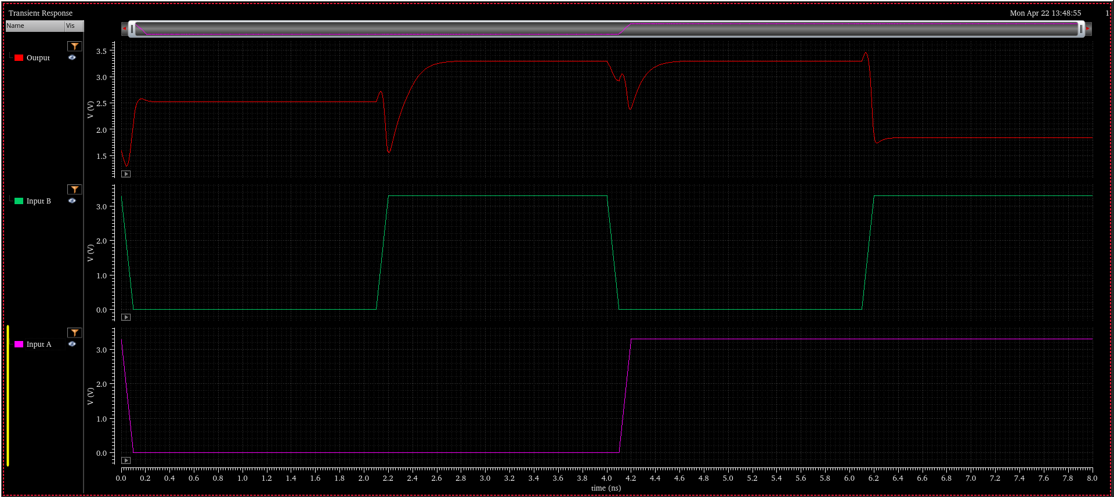

Testbench for XORC
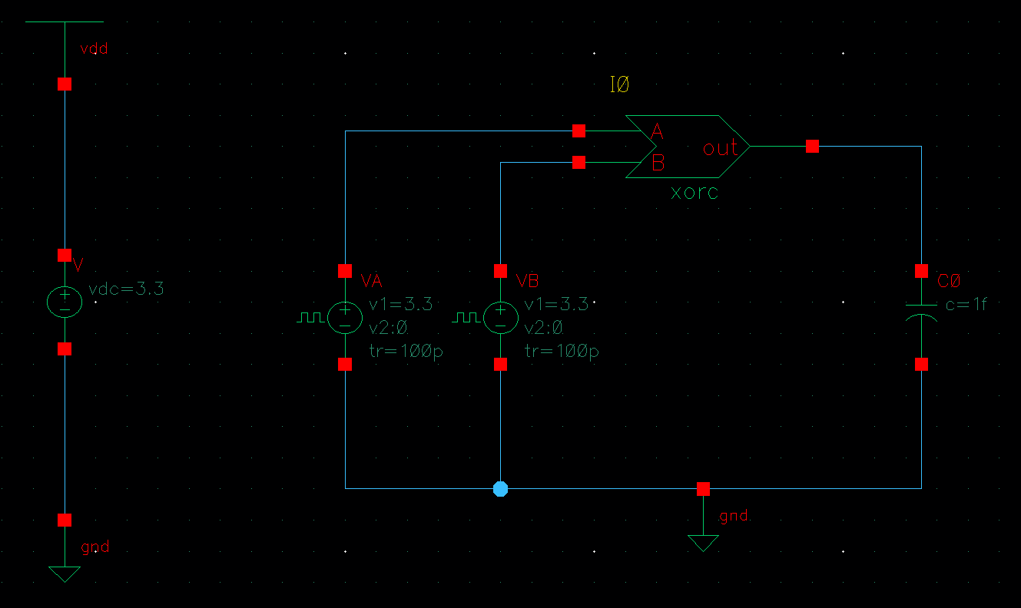

Testbench for XORT
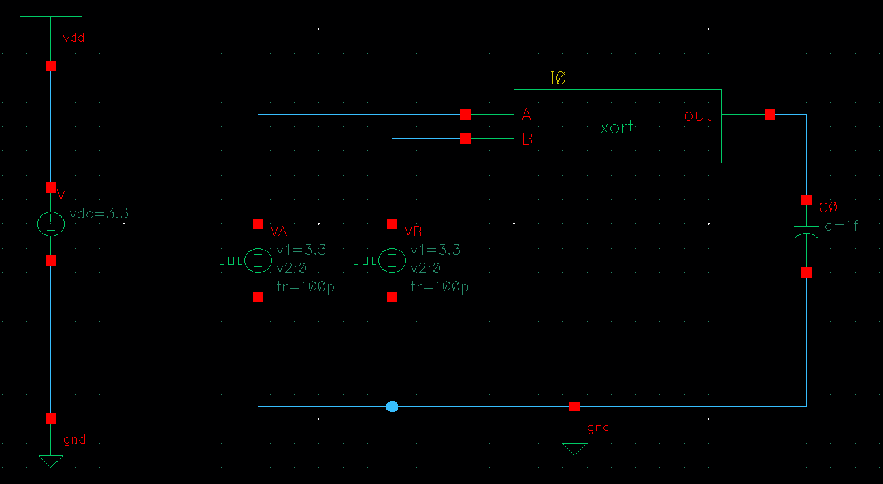

Testbench output for XORT
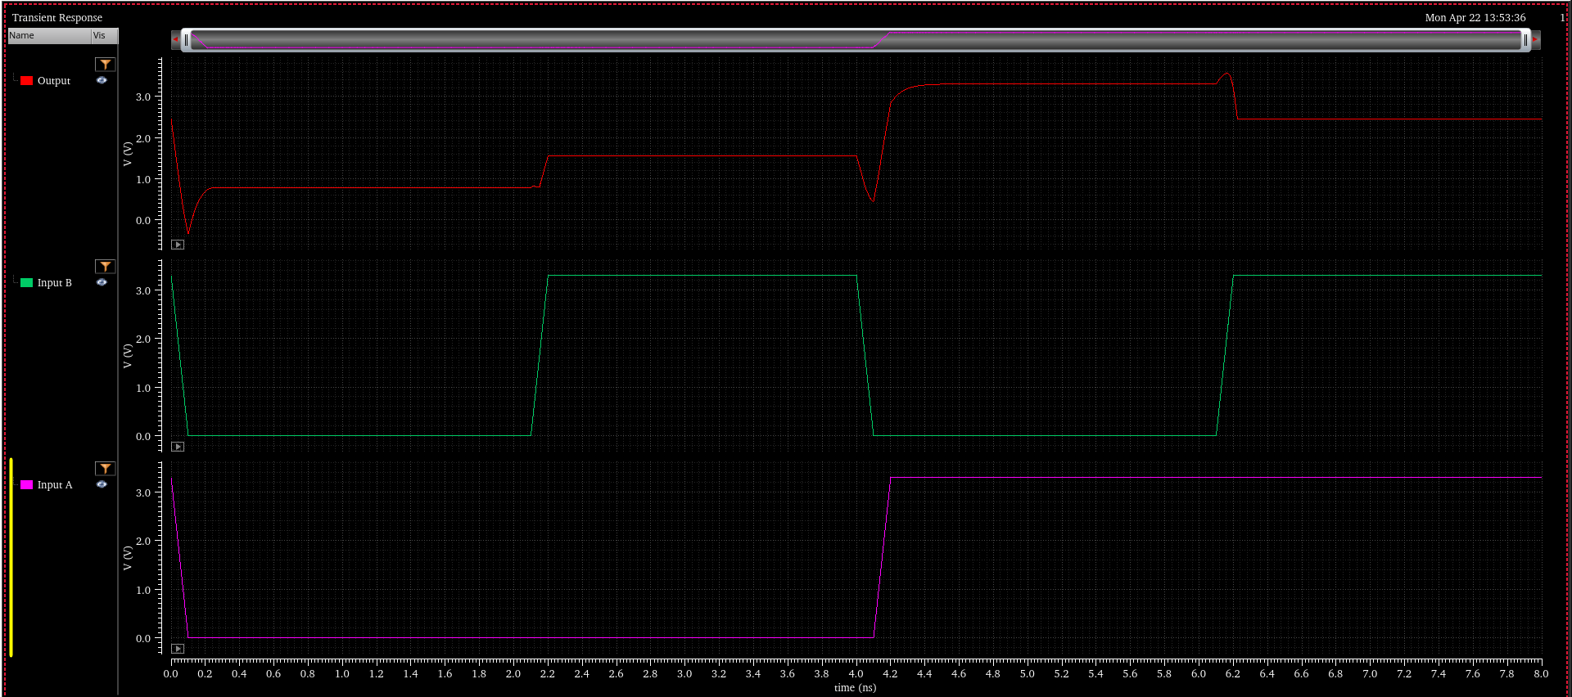

Part 3
Area of layout (XORC) = 9.4 x 23.05 = 216.67 um^2
Area of layout (XORT) = 8.5 x 13.475 = 114.537 um^2

Part 4
Power consumption of XORC = 2.247e-6
Power consumption of XORT = 2.247e-6

